|  |  |  |  |  |  |
| --- | --- | --- | --- | --- | --- |
| ode |  | N ot Attended | Se7-4c* -  Appointment letter is not issued | minutæ —go | '-Estuy |
| El exp IS ict.png exp IS dep.png |

R»pointm ent letter is issued exp 19 state..rg exp 20 deplcy.prg



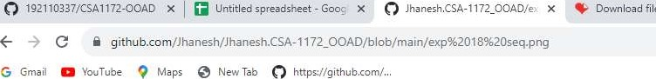

|  |  |  |  |  |  |  |  |
| --- | --- | --- | --- | --- | --- | --- | --- |
| ED code | Jhanesh.CSA-1172_00AD/exp  Jhanesh | 18 seq.png  files via upload |  | 2: Chcunents of the canddate  4: Acceptance of the documnts | Se7-4c* - 3: Wrifeatm of docunents | minutæ —go | '-Estuy |
| El  exp  IS  ict.png  IS |

exp 19 state..rg exp 20 deplcy.prg

O



09:34

07-08-2023

|  |  |  |  |  |  |  |  |
| --- | --- | --- | --- | --- | --- | --- | --- |
| ED code | Jhanesh.CSA-1172_00AD/exp  Jhanesh  18.8 ke |  | Cand&te 1 | CarWOte 3 | Se7-4c* - | minutæ —go | '-Estuy |
| El  exp  IS  ict.png |